Obtaining your FAN
Go to DFA website:
http://www.durhamfa.com/

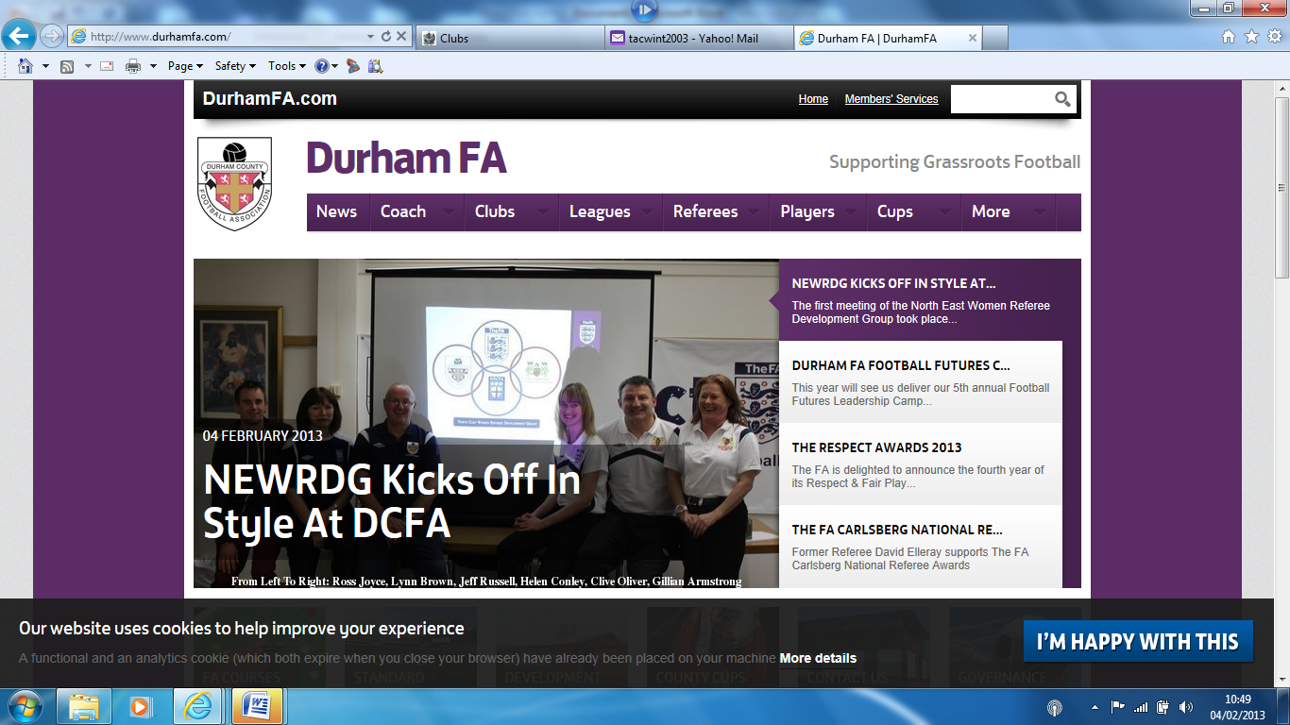
Go to Members’ Services
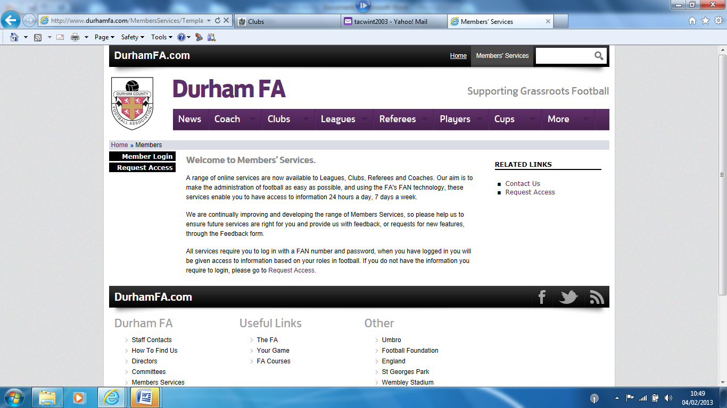
If you have login details go to Member Login, if not go to Request Access
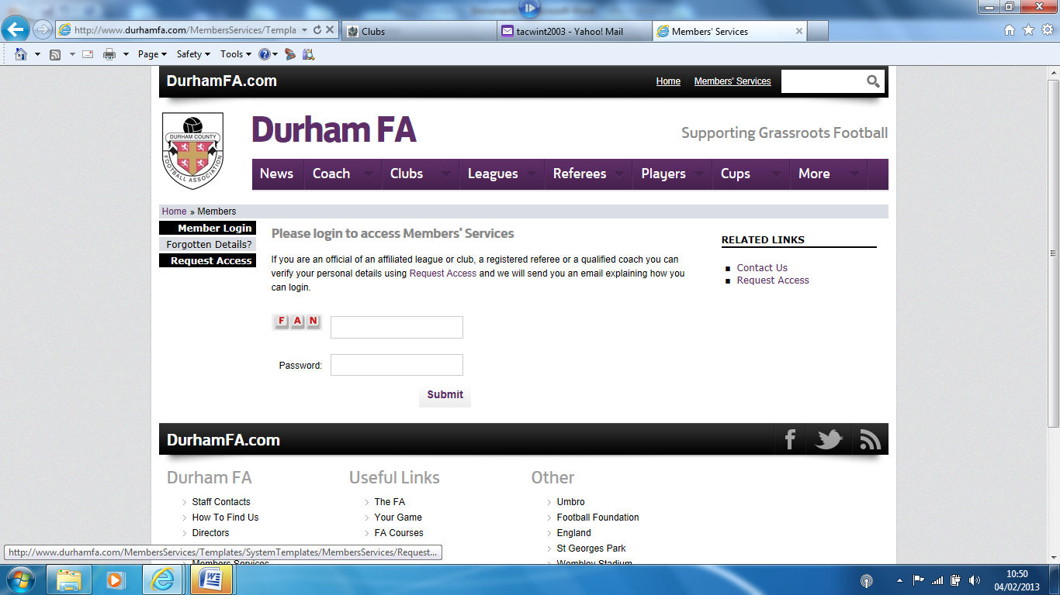

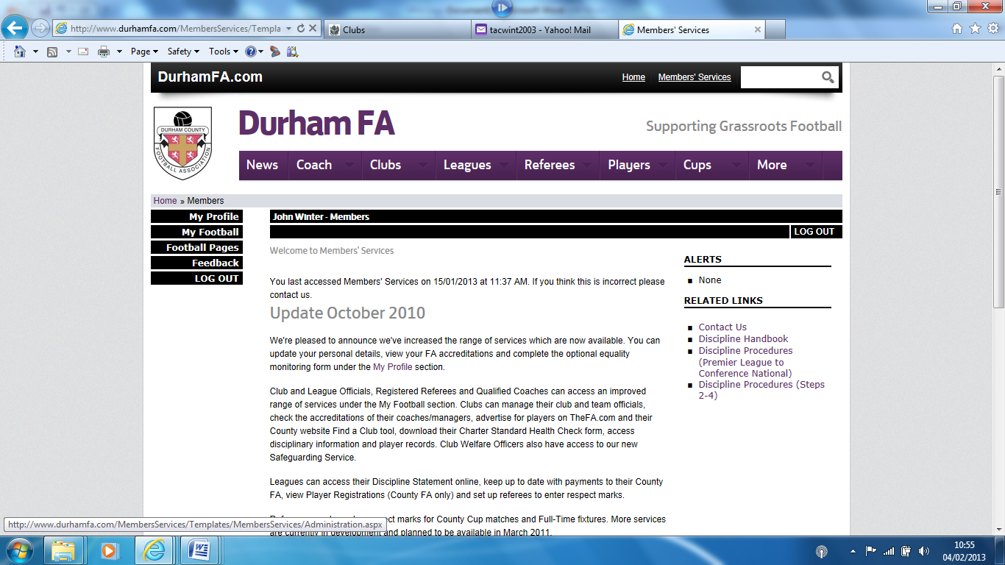
Go to My Football
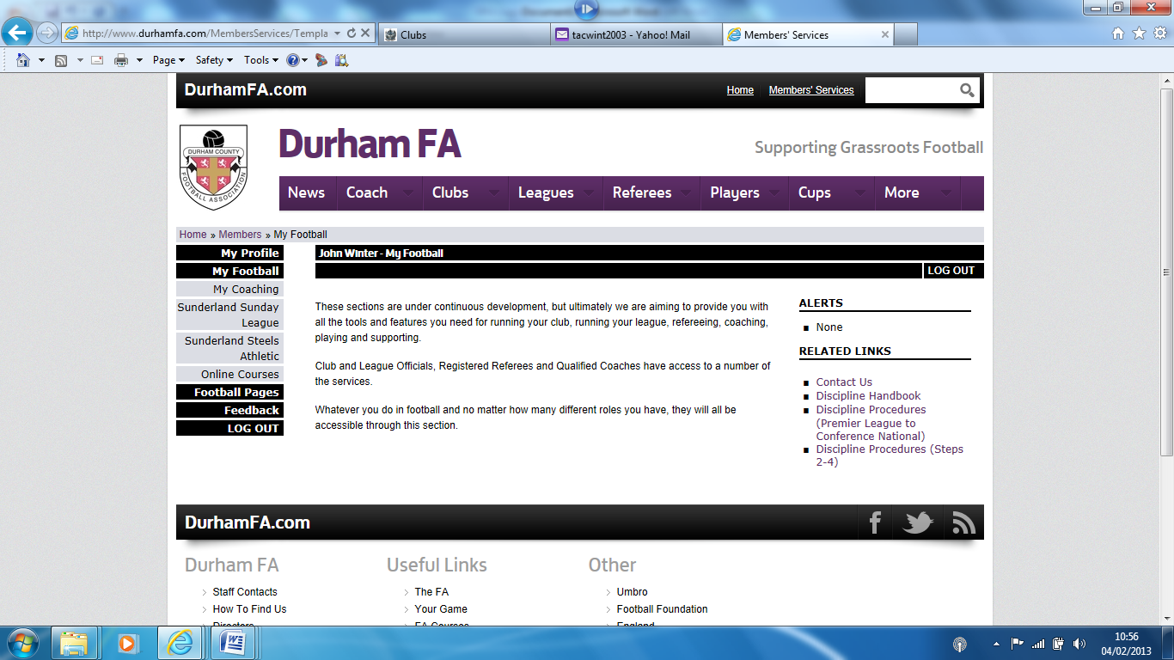
Go to your club
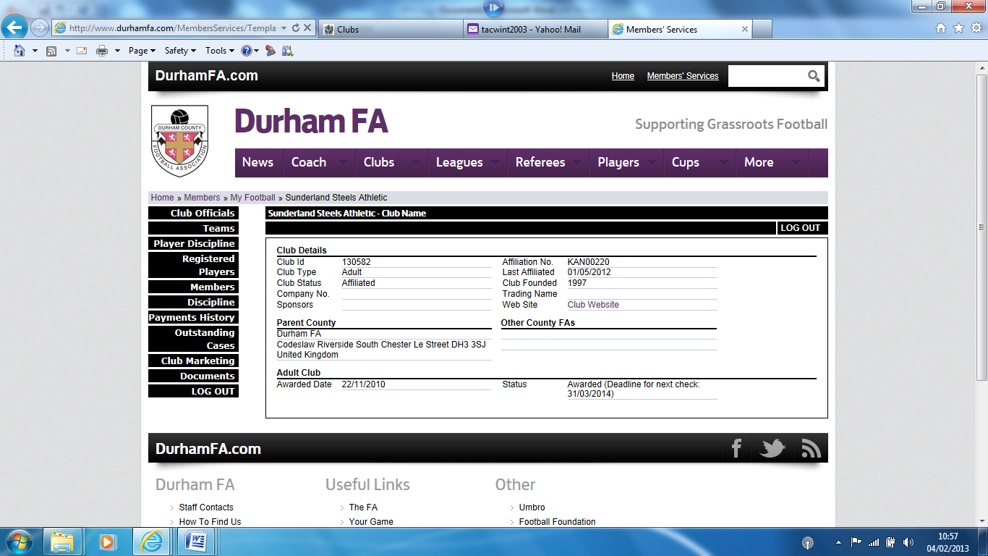
Go to Members – you will find FAN in left-hand column of table

